**NODE JS - EXERCISES**

1. Design a code to create a Node server running at **http://localhost:3000** with appropriate console log.

const http =require('http');

const server = http.createServer((req, res) => {

    console.log("Hello");

})

server.listen(3000,()=>{

    console.log("Server is running");

})

OUTPUT:

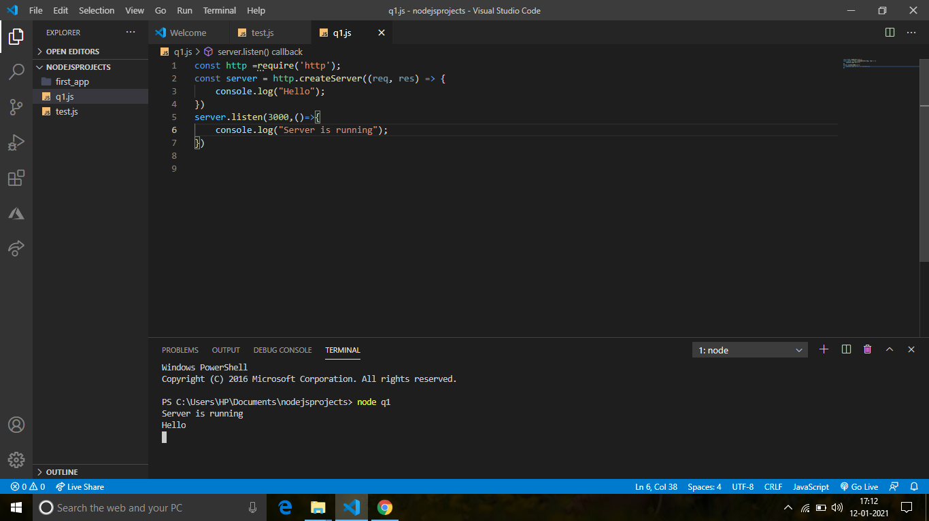

1. Design a code to create a Node server running at **http://localhost:3000** with the following message,

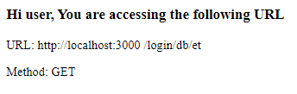

const http= require("http");

     const server=http.createServer((req,res) =>{

        res.writeHead(200,{'Content-type':'text/html'});

        res.write("<h3>Hi user, You are accessing the following URL</h3>");

        res.write(`URL: ${req.url} <br><br>`);

        res.write(`Method: ${req.method}`);

        res.end();

     })

     server.listen(3000,()=>{

        console.log("Server is running");

     })

OUTPUT:

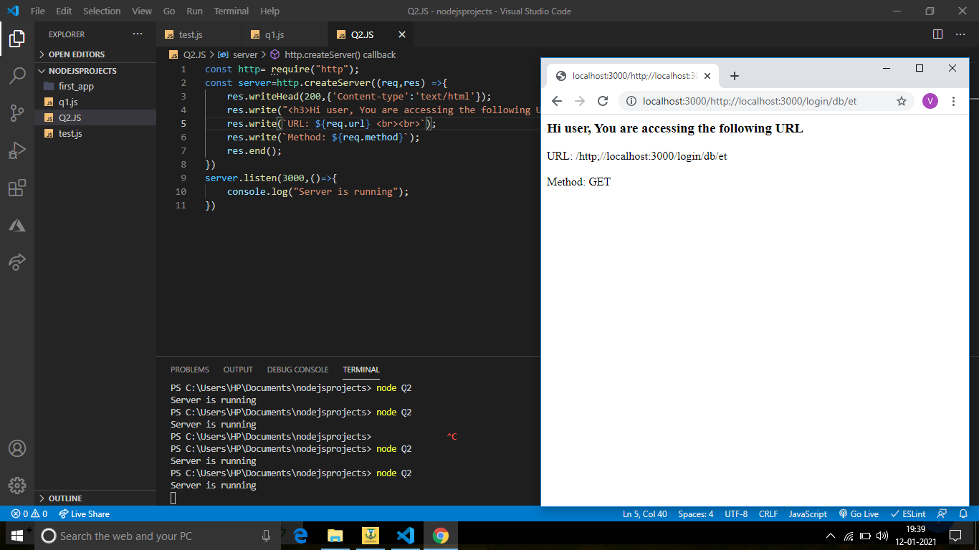

1. Design a code to create the below registration form running at **http://localhost:3030** using NodeJS. On Submitting the form, data should be displayed in next page.

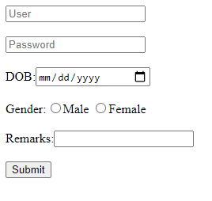

Data displayed on **/validate**

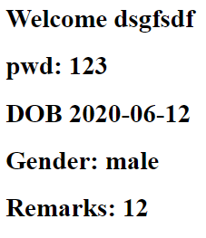

Program:

const http=require('http');

const server=http.createServer((req,res) =>{

    if(req.url==='/3030'){

    res.writeHead(200,{'Content-type':'text/html'});

    res.write("<form action='/validate' method='POST'>");

    res.write("<input type='text' placeholder='User' name='username'><br><br>");

    res.write("<input type='text' placeholder='Password' name='password'><br><br>");

    res.write("DOB:<input type='date'  placeholder='mm/dd/yyyy' name='date'><br><br>");

    res.write("Gender:<input type='radio' name='Gender' value='Male'>Male &nbsp;<input type='radio' name='Gender' value='Female'>Female<br><br>");

    res.write("Remarks:<input type='text'  name='Remarks'><br><br>");

    res.write("<button type='submit'> Submit</button></form>");

    res.end();

    }

    if(req.url === '/validate' && req.method==='POST')

    {

        let arr=[];

        let username;

        let password;

        let date;

        let gen;

        let remarks;

        req.on('data',chunk =>{

            arr.push(chunk);

        });

        req.on('end',()=>{

            arr=Buffer.concat(arr).toString();

            username=arr.split('&')[0].split('=')[1];

            password=arr.split('&')[1].split('=')[1];

            date=arr.split('&')[2].split('=')[1];

            gen=arr.split('&')[3].split('=')[1];

            remarks=arr.split('&')[4].split('=')[1];

            res.writeHead(200,{'Content-type':'text/html'});

            res.end(`<b>Welcome ${username} <br><br>

                            pwd: ${password} <br><br>

                            DOB: ${date} <br><br>

                            Gender:${gen} <br><br>

                            Remarks: ${remarks} </b>`);

        });

    }

})

server.listen(3030,()=>{

    console.log("Server is running at port 3030");

})

OUTPUT:

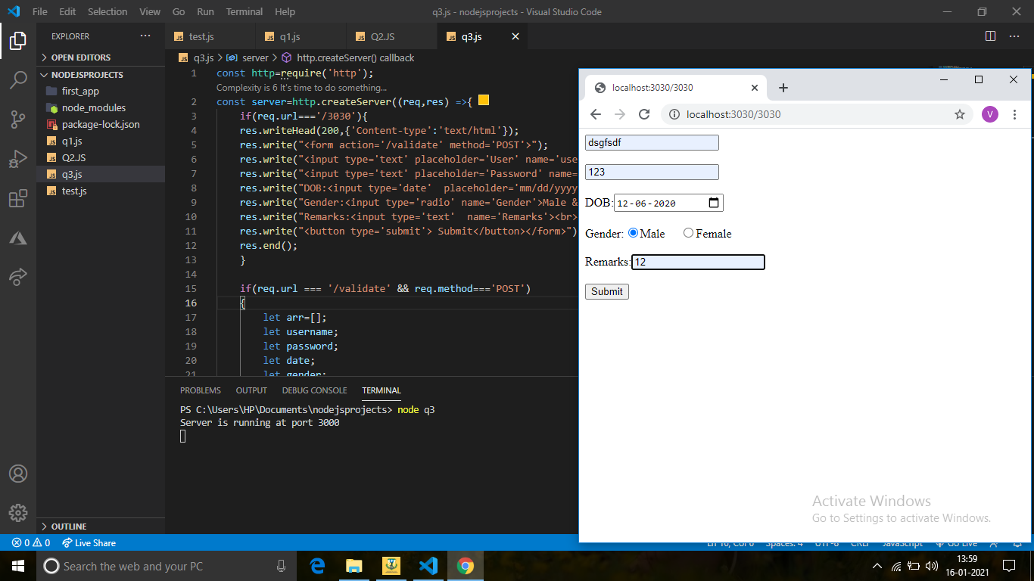

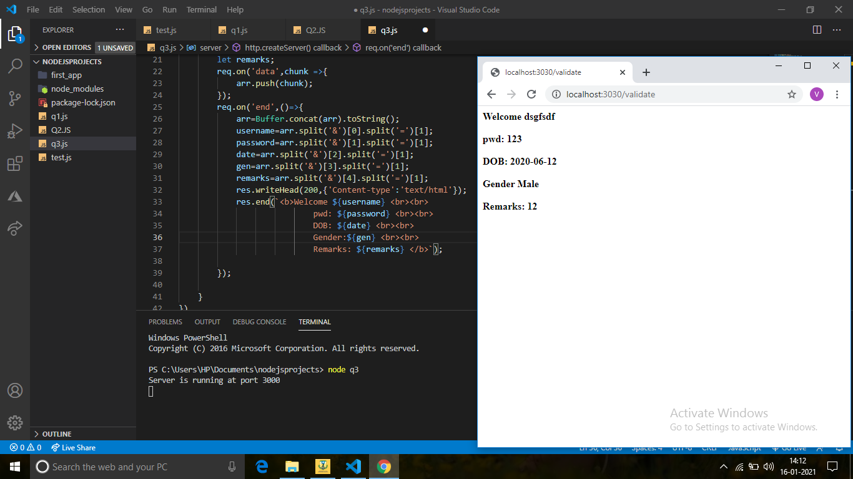

1. Design a code to create the below form running at **http://localhost:3030** using NodeJS. On Submitting the form, data should be displayed in next page.

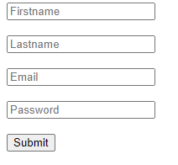

PROGRAM:

const http=require('http');

const server=http.createServer((req,res)=>{

    if(req.url==='/3000')

    {

        res.writeHead(200,{'Content-type':'text/html'});

        res.write("<form action='/validate' method='POST'>");

        res.write("<input type='email' placeholder='Email' name='email'><br><br>");

        res.write("<input type='password' placeholder='Password' name='password'><br><br>");

        res.write("<button type='submit'> Submit</button></form>");

        res.end();

    }

    if(req.url === '/validate' && req.method==='POST')

    {

        let arr=[];

        let email;

        let password;

        req.on('data',chunk =>{

            arr.push(chunk);

        });

        req.on('end',()=>{

            arr=Buffer.concat(arr).toString();

            email=arr.split('&')[0].split('=')[1];

            password=arr.split('&')[1].split('=')[1];

            res.writeHead(200,{'Content-type':'text/html'});

            res.end(`<b>Welcome ${email} <br><br>

                            pwd: ${password} </b>`);

        });

    }

})

server.listen(3000,()=>{

    console.log("Server is running at port 3000");

})

OUTPUT:

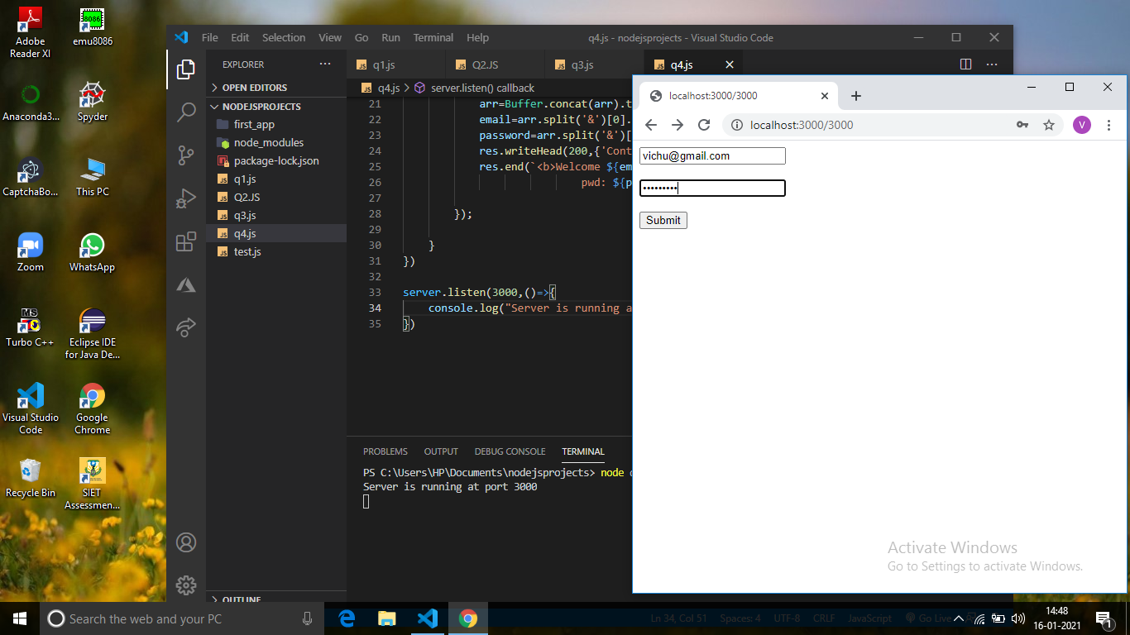

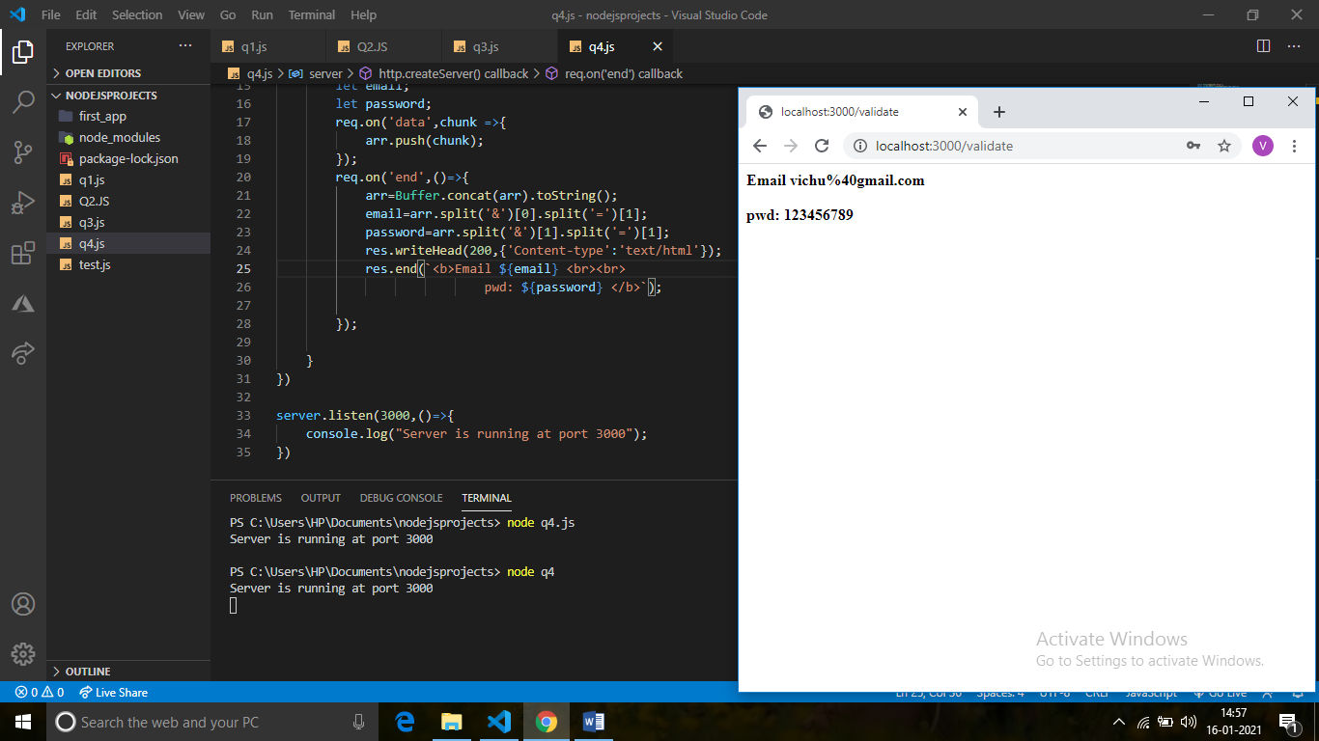

1. Design a code to create the below registration form running at **http://localhost:3030** using ExpressJs. On Submitting the form, data should be displayed in next page.



PROGRAM IN HTML:

<!DOCTYPE html>

<head></head>

<body>

    <form action='/validate' method='POST'>

        <input type='text' placeholder='User' name='username'><br><br>

        <input type='text' placeholder='Password' name='password'><br><br>

        DOB:<input type='date'  placeholder='mm/dd/yyyy' name='date'><br><br>

        Gender:<input type='radio' name='Gender' value='Male'>Male &nbsp;<input type='radio' name='Gender' value='Female'>Female<br><br>

        Remarks:<input type='text'  name='Remarks'><br><br>

       <button type='submit'> Submit</button></form>

</body>

</html>

PROGRAM IN EXPRESS JS

var express=require('express');

var app=express();

var bodyParser=require('body-parser');

app.use(bodyParser.urlencoded({extended:false}));

app.use(express.static(__dirname));

app.use('/q5',function(req,res){

    console.log('hi');

    res.sendFile(__dirname +'/views/q5.html');

})

app.post('/validate',function(req,res){

        var username=req.body.username;

        var password=req.body.password;

        var date=req.body.date;

        var gen=req.body.Gender;

        var remarks=req.body.Remarks;

        console.log("data submitted");

        res.send(`<b>Welcome ${username} <br><br>

        pwd: ${password} <br><br>

        DOB: ${date} <br><br>

        Gender:${gen} <br><br>

        Remarks: ${remarks} </b>`);

})

app.listen(3030,()=>{

    console.log("server is running at the port 3030");

})

OUTPUT:

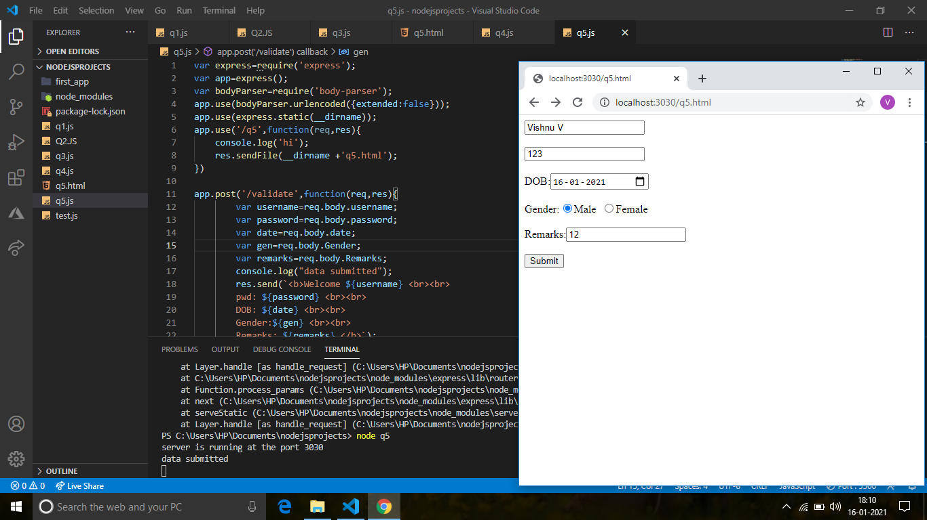

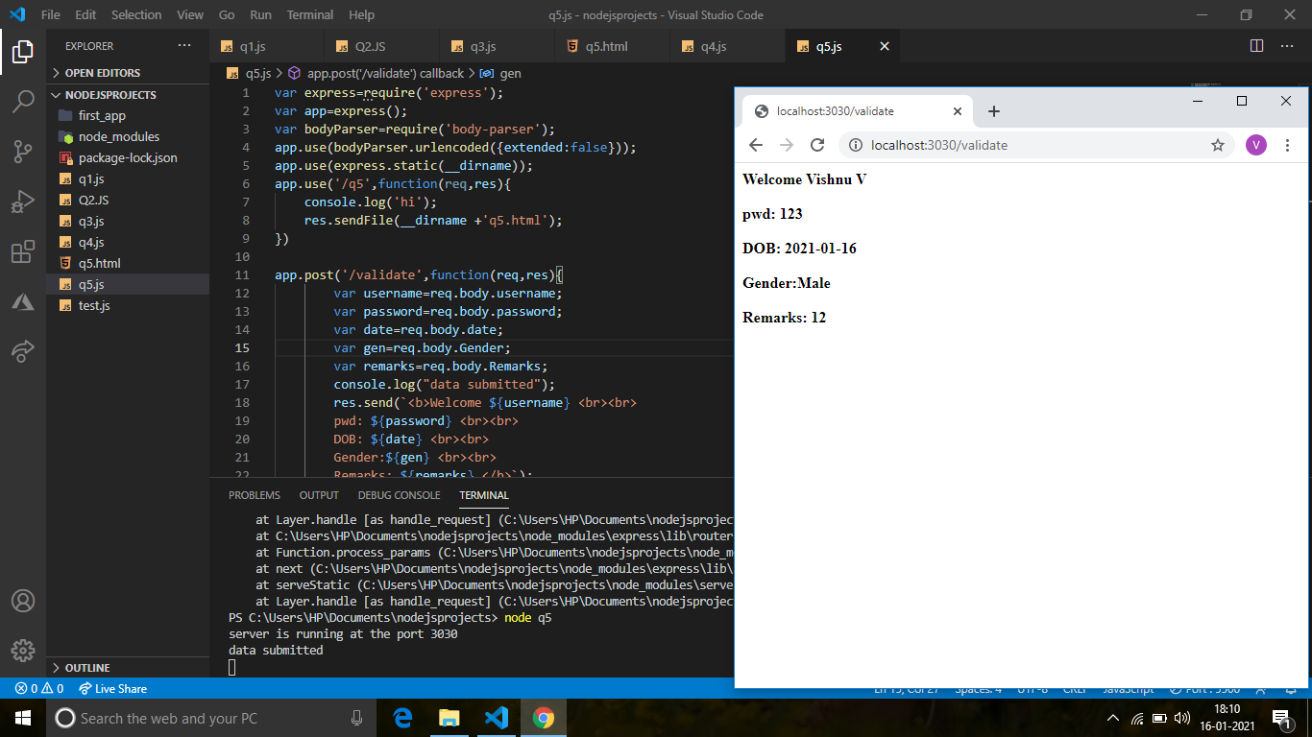

1. Design a code to create the below form running at **http://localhost:3030** using ExpressJs. On Submitting the form, data should be displayed in next page.



HTML:

<!DOCTYPE html>

<head></head>

<body>

    <form action='/validate' method='POST'>

        <input type='text' placeholder='Email' name='email'><br><br>

        <input type='text' placeholder='Password' name='password'><br><br>

        <button type='submit'> Submit</button></form>

</body>

</html>

EXPRESS JS:

var express=require('express');

var app=express();

var bodyParser=require('body-parser');

app.use(bodyParser.urlencoded({extended:false}));

app.use(express.static(__dirname));

app.use('/q6',function(req,res){

    console.log('hi');

    res.sendFile(__dirname +'/views/q6.html');

})

app.post('/validate',function(req,res){

    var email=req.body.email;

    var password=req.body.password;

    console.log("data submitted");

    res.send(`<b>Email: ${email} <br><br>

    pwd: ${password} </b>`);

})

app.listen(3000,()=>{

    console.log("server is running at the port 3030");

})

OUTPUT:

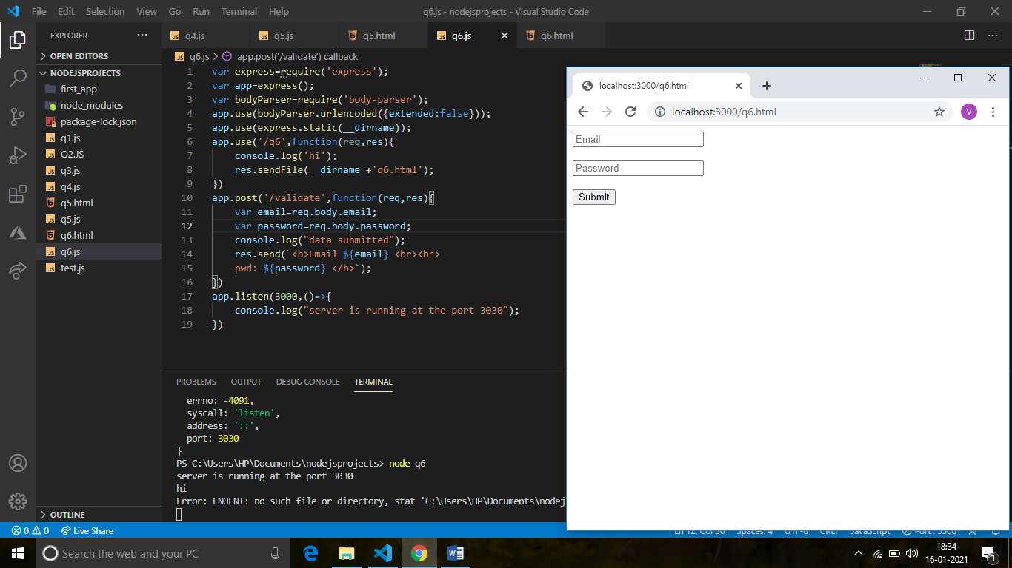

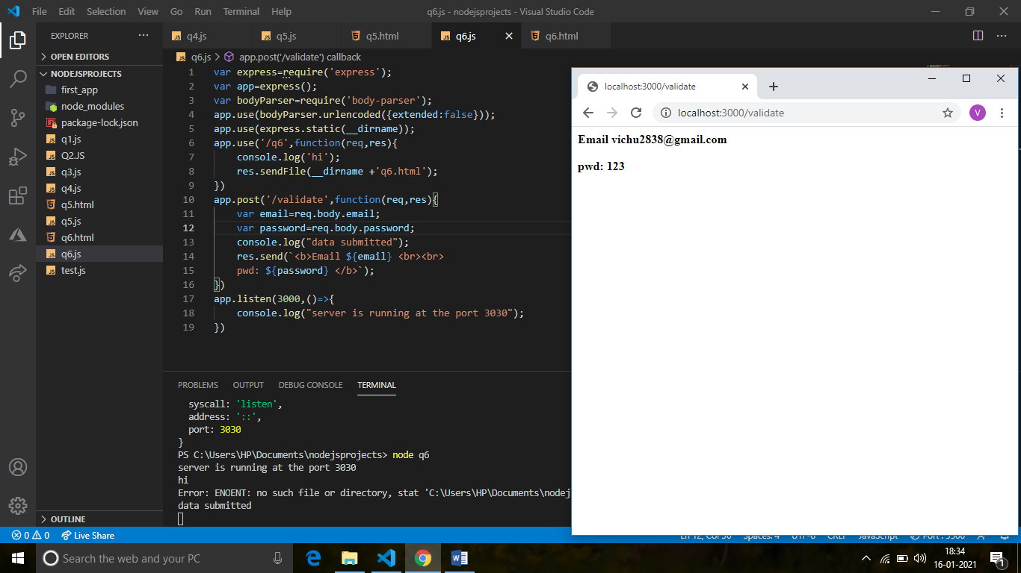

1. Render the below html pages using ExpressJs,
   1. home.html 🡪 /home
   2. login.html 🡪 /login
   3. signup.html 🡪 /signup
   4. forgot password.html 🡪/user/fgpwd
   5. 404.page 🡪 for all other invalid cases

HTML home page:

<!DOCTYPE html>

<html lang="en">

<head>

  <title>HOME PAGE</title>

  <meta charset="utf-8">

  <meta name="viewport" content="width=device-width, initial-scale=1">

  <link rel="stylesheet" href="https://maxcdn.bootstrapcdn.com/bootstrap/4.5.2/css/bootstrap.min.css">

  <script src="https://ajax.googleapis.com/ajax/libs/jquery/3.5.1/jquery.min.js"></script>

  <script src="https://cdnjs.cloudflare.com/ajax/libs/popper.js/1.16.0/umd/popper.min.js"></script>

  <script src="https://maxcdn.bootstrapcdn.com/bootstrap/4.5.2/js/bootstrap.min.js"></script>

  <style>

  .fakeimg {

    height: 200px;

    background: #aaa;

  }

  </style>

</head>

<body>

<div class="jumbotron text-center" style="margin-bottom:0">

  <h1>HOME PAGE</h1>

  <p>Resize this responsive page to see the effect!</p>

</div>

<nav class="navbar navbar-expand-sm bg-dark navbar-dark">

  <a class="navbar-brand" href="#">Navbar</a>

  <button class="navbar-toggler" type="button" data-toggle="collapse" data-target="#collapsibleNavbar">

    <span class="navbar-toggler-icon"></span>

  </button>

  <div class="collapse navbar-collapse" id="collapsibleNavbar">

    <ul class="navbar-nav">

      <li class="nav-item">

        <a class="nav-link" href="#">Link</a>

      </li>

      <li class="nav-item">

        <a class="nav-link" href="#">Link</a>

      </li>

      <li class="nav-item">

        <a class="nav-link" href="#">Link</a>

      </li>

    </ul>

  </div>

</nav>

<div class="container" style="margin-top:30px">

  <div class="row">

    <div class="col-sm-4">

      <h2>About Me</h2>

      <h5>Photo of me:</h5>

      <div class="fakeimg">Fake Image</div>

      <p>Some text about me in culpa qui officia deserunt mollit anim..</p>

      <h3>Some Links</h3>

      <p>Lorem ipsum dolor sit ame.</p>

      <ul class="nav nav-pills flex-column">

        <li class="nav-item">

          <a class="nav-link active" href="#">Active</a>

        </li>

        <li class="nav-item">

          <a class="nav-link" href="#">Link</a>

        </li>

        <li class="nav-item">

          <a class="nav-link" href="#">Link</a>

        </li>

        <li class="nav-item">

          <a class="nav-link disabled" href="#">Disabled</a>

        </li>

      </ul>

      <hr class="d-sm-none">

    </div>

    <div class="col-sm-8">

      <h2>TITLE HEADING</h2>

      <h5>Title description, Dec 7, 2017</h5>

      <div class="fakeimg">Fake Image</div>

      <p>Some text..</p>

      <p>Sunt in culpa qui officia deserunt mollit anim id est laborum consectetur adipiscing elit, sed do eiusmod tempor incididunt ut labore et dolore magna aliqua. Ut enim ad minim veniam, quis nostrud exercitation ullamco.</p>

      <br>

      <h2>TITLE HEADING</h2>

      <h5>Title description, Sep 2, 2017</h5>

      <div class="fakeimg">Fake Image</div>

      <p>Some text..</p>

      <p>Sunt in culpa qui officia deserunt mollit anim id est laborum consectetur adipiscing elit, sed do eiusmod tempor incididunt ut labore et dolore magna aliqua. Ut enim ad minim veniam, quis nostrud exercitation ullamco.</p>

    </div>

  </div>

</div>

<div class="jumbotron text-center" style="margin-bottom:0">

  <p>Footer</p>

</div>

</body>

</html>

LOGIN PAGE:

<html>

    <head>

        <link rel="stylesheet" type="text/css" href="/public/css/signup.css">

        <script src="https://kit.fontawesome.com/a43c0f77ad.js" crossorigin="anonymous"></script>

    </head>

    <body>

    <div class ="container">

    <div class="header">

        <h2>LOGIN</h2>

    </div>

    <form class="form" action="https://www.appcues.com/blog/best-practices-for-an-effective-product-welcome-page" id="form">

        <div class="form-control">

         <input type="text" placeholder="Hello12@gmail.com" id="Email">

         <i class="fas fa-check-circle"></i>

         <i class="fas fa-exclamation-circle"></i>

         <small>Error message</small>

        </div>

        <div class="form-control">

         <input type="password" placeholder="password" id="Password">

         <i class="fas fa-check-circle"></i>

         <i class="fas fa-exclamation-circle"></i>

         <small>Error message</small>

        </div>

        <button>Login</button><br><br>

        Don't have an account ? <a href="/views/signup.html">Sign up</a><br><br>

        forgot password ? <a href="/views/Forgotpassword.html">Click here</a><br>

         <script src="/public/js/login.js"></script>

    </form>

</div>

</body>

</html>

SIGNUP PAGE:

<html>

    <head>

        <link rel="stylesheet" type="text/css" href="/public/css/signup.css">

        <script src="https://kit.fontawesome.com/a43c0f77ad.js" crossorigin="anonymous"></script>

    </head>

    <body>

    <div class ="container">

    <div class="header">

        <h2>REGISTER</h2>

    </div>

    <form class="form" action="/views/login.html" id="form">

        <div class="form-control">

         <input type="text" placeholder="Hello12" id="username">

         <i class="fas fa-check-circle"></i>

         <i class="fas fa-exclamation-circle"></i>

         <small>Error message</small>

        </div>

        <div class="form-control">

            <input type="text" placeholder="57" id="rollnumber">

            <i class="fas fa-check-circle"></i>

            <i class="fas fa-exclamation-circle"></i>

            <small>Error message</small>

        </div>

        <div class="form-control">

            <input type="text" placeholder="hello@gmail.com" id="Email">

            <i class="fas fa-check-circle"></i>

            <i class="fas fa-exclamation-circle"></i>

            <small>Error message</small>

        </div>

        <div class="form-control">

            <input type="password" placeholder="password" id="Password">

            <i class="fas fa-check-circle"></i>

            <i class="fas fa-exclamation-circle"></i>

            <small>Error message</small>

        </div>

        <div class="form-control">

            <input type="password" placeholder="Confirm password" id="password2">

            <i class="fas fa-check-circle"></i>

            <i class="fas fa-exclamation-circle"></i>

            <small>Error message</small>

        </div>

        <div>Gender:<input type="radio" name="Gender" id="radio"  value="Male">Male<input type="radio" name="Gender" id="radio" value="Female">Female<input type="radio" name="Gender" id="radio" value="Others">Others</div><br>

        <h6 id="error" style= "color:#e74c3c"> </h6>

         <button>Submit</button><br>

         Already have an account ? <a href="/views/login.html">Sign in</a>

         <script src="/public/js/signup.js"></script>

 </form>

</div>

</body>

</html>

FORGOT PASSWORD PAGE:

<html>

    <head>

        <link rel="stylesheet" type="text/css" href="/public/css/signup.css">

        <script src="https://kit.fontawesome.com/a43c0f77ad.js" crossorigin="anonymous"></script>

    </head>

    <body>

    <div class ="container">

    <div class="header">

        <h2>FORGOT PASSWORD</h2>

    </div>

    <form class="form" action="/views/login.html" id="form">

        <div class="form-control">

         <input type="text" placeholder="Hello12@gmail.com" id="Email">

         <i class="fas fa-check-circle"></i>

         <i class="fas fa-exclamation-circle"></i>

         <small>Error message</small>

        </div>

        <div class="form-control">

         <input type="password" placeholder="password" id="Password">

         <i class="fas fa-check-circle"></i>

         <i class="fas fa-exclamation-circle"></i>

         <small>Error message</small>

        </div>

        <button>Reset</button>

         <script src="/public/js/login.js"></script>

    </form>

</div>

</body>

</html>

PROGRAM IN EXPRESS JS:

var express=require('express');

var app=express();

var bodyParser=require('body-parser');

app.use(bodyParser.urlencoded({extended:false}));

app.use(express.static(__dirname));

app.get('/home',function(req,res){

       console.log("Welcome to Home page");

       res.sendFile(__dirname+'/views/home.html');

})

app.get('/login',function(req,res){

    console.log("Welcome to login page");

    res.sendFile(__dirname+'/views/login.html');

})

app.get('/signup',function(req,res){

    console.log("Welcome to signup page");

    res.sendFile(__dirname+'/views/signup.html');

})

app.get('/user/fgpwd',function(req,res){

    console.log("Welcome to forgot password page");

    res.sendFile(__dirname+'/views/Forgotpassword.html');

})

app.get('/',function(req,res){

    console.log("page not found");

    res.send(`<b>404 page not found</b>`)

})

app.listen(3000,()=>{

    console.log("server is running at the port 3000");

})

OUTPUT:

A)

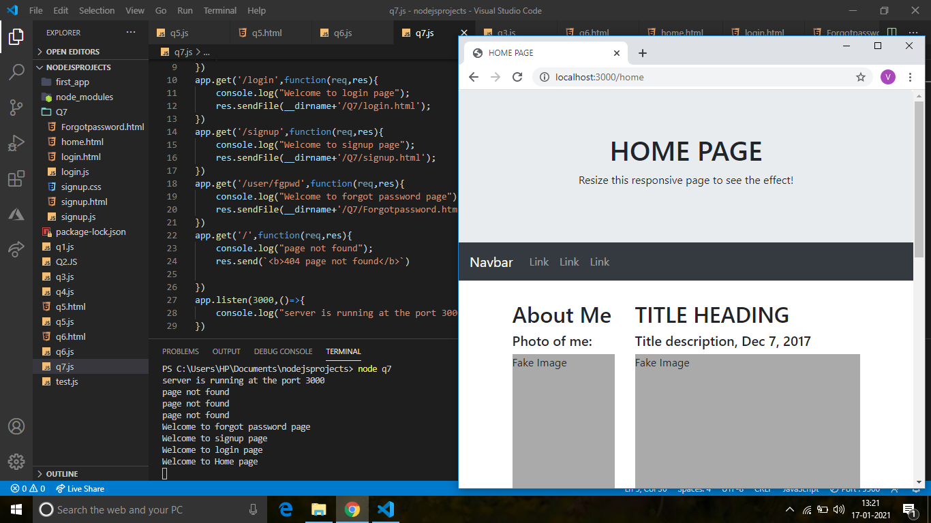

B)

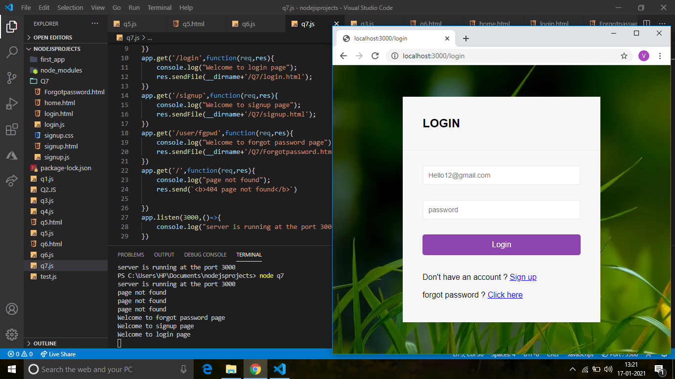

C)

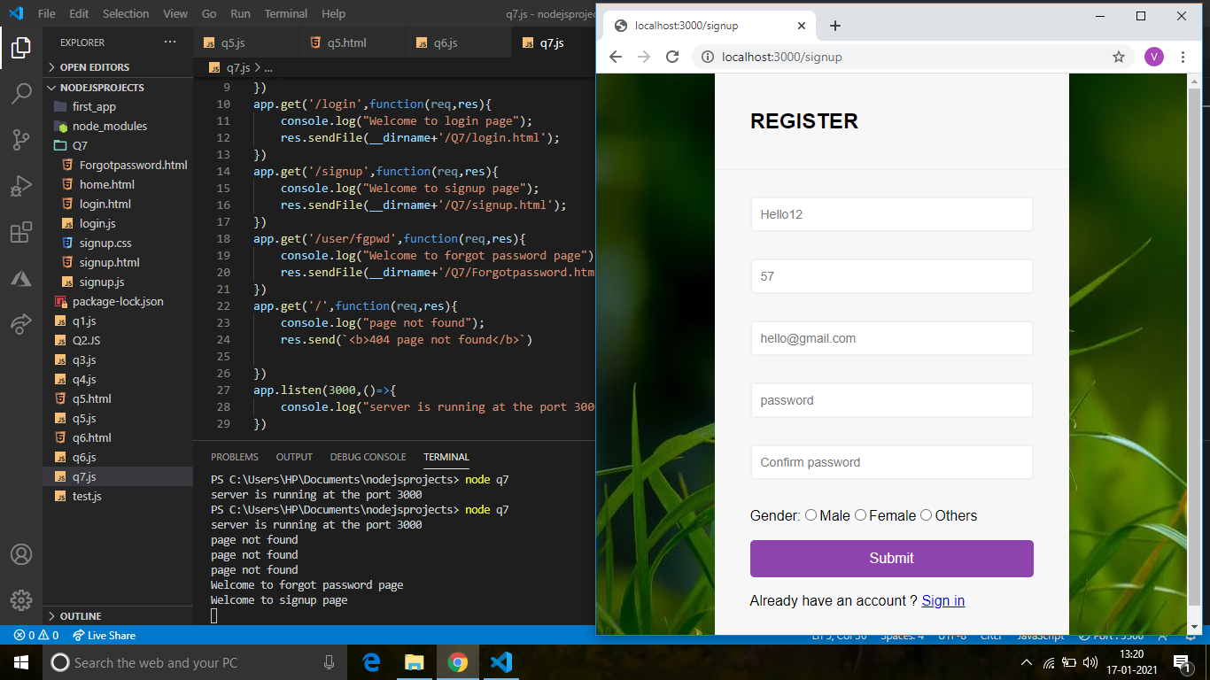

D)

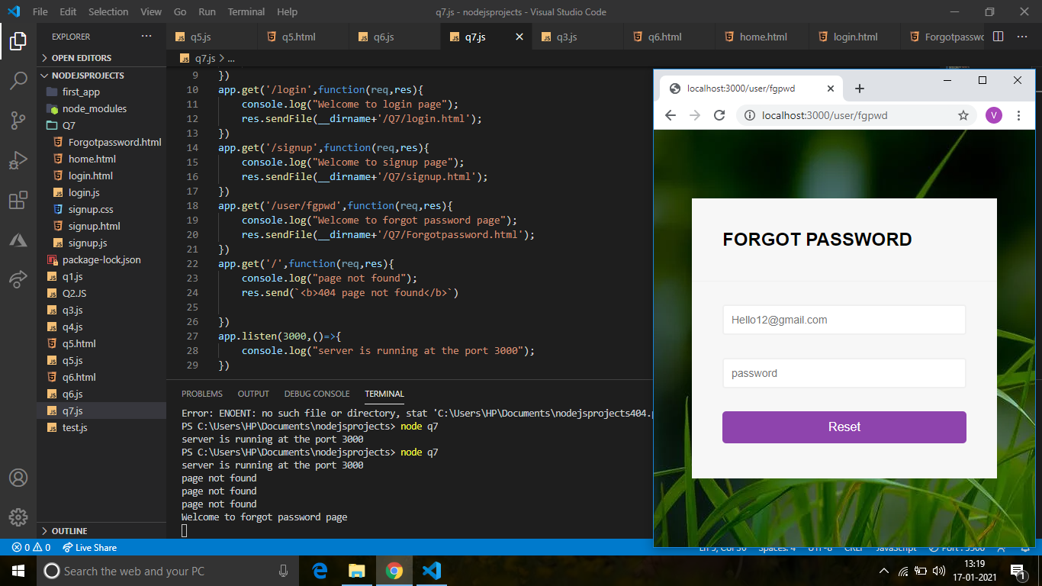

E)

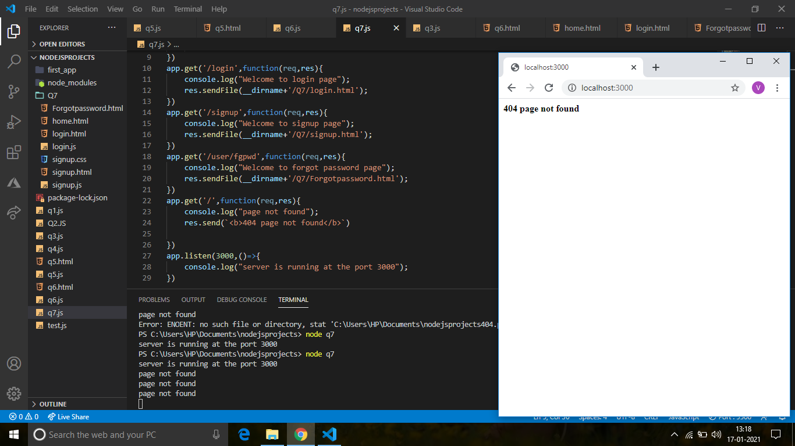

1. Create a dashboard page with Name and greetings message which gets redirected after successful login

PROGRAM IN HTML:

<html>

    <head>

        <link rel="stylesheet" type="text/css" href="/public/css/signup.css">

        <script src="https://kit.fontawesome.com/a43c0f77ad.js" crossorigin="anonymous"></script>

    </head>

    <body>

    <div class ="container">

    <div class="header">

        <h2>LOGIN</h2>

    </div>

    <form class="form" action="/validate" method='POST' id="form">

        <div class="form-control">

         <input type="text" placeholder="Username" id="username" name="username">

         <i class="fas fa-check-circle"></i>

         <i class="fas fa-exclamation-circle"></i>

         <small>Error message</small>

        </div>

        <div class="form-control">

         <input type="password" placeholder="password" id="Password" name="password">

         <i class="fas fa-check-circle"></i>

         <i class="fas fa-exclamation-circle"></i>

         <small>Error message</small>

        </div>

        <button>Login</button><br><br>

        Don't have an account ? <a href="/views/signup.html">Sign up</a><br><br>

        forgot password ? <a href="/views/Forgotpassword.html">Click here</a><br>

         <script src="/public/js/q8login.js"></script>

    </form>

</div>

</body>

</html>

PROGRAM IN EXPRESS JS :

var express=require('express');

var app=express();

var bodyParser=require('body-parser');

app.use(bodyParser.urlencoded({extended:false}));

app.use(express.static(__dirname));

app.use('/q8',function(req,res){

    console.log('Welcome to Login Page');

    res.sendFile(__dirname +'/views/q8.html');

})

app.post('/validate',function(req,res){

    var username=req.body.username;

    var password=req.body.password;

    console.log("Login done Successfully");

    res.send(`<b>Hello  ${username} have a Good day..! </b>`);

})

app.listen(3000,()=>{

    console.log("server is running at the port 3000");

})

OUTPUT:

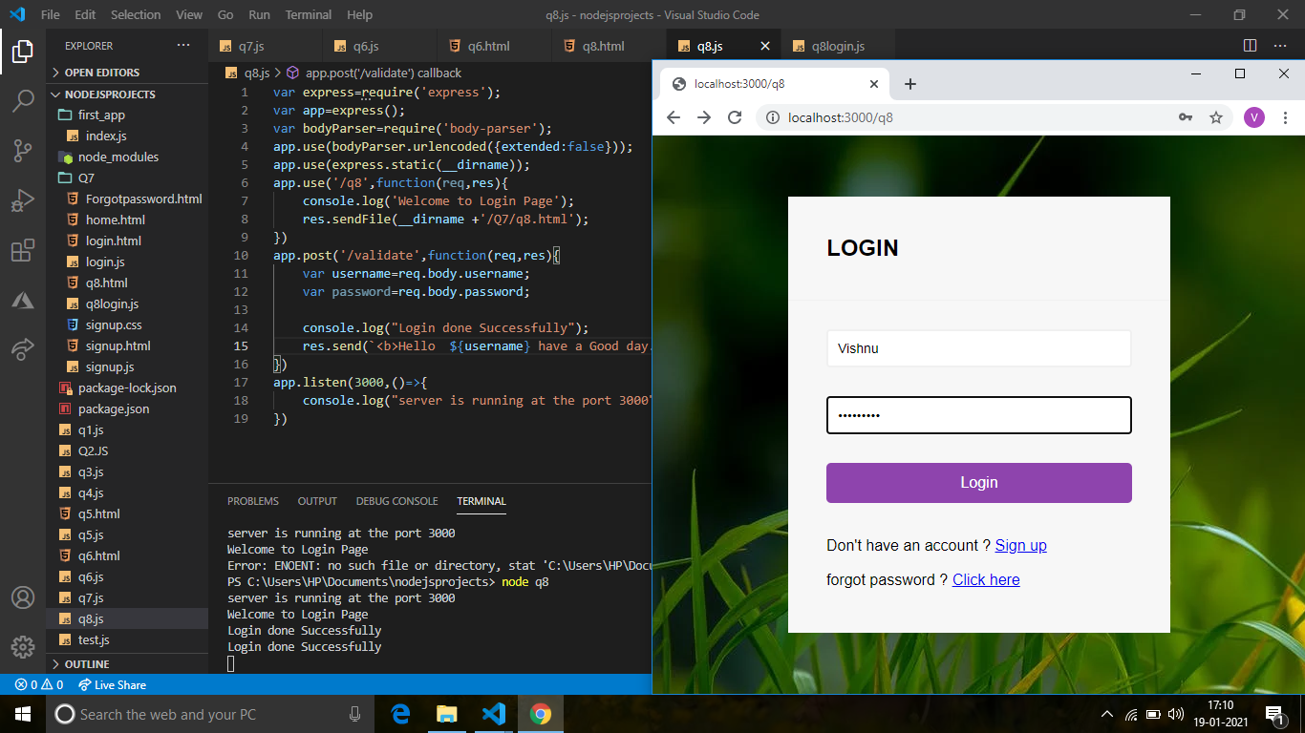

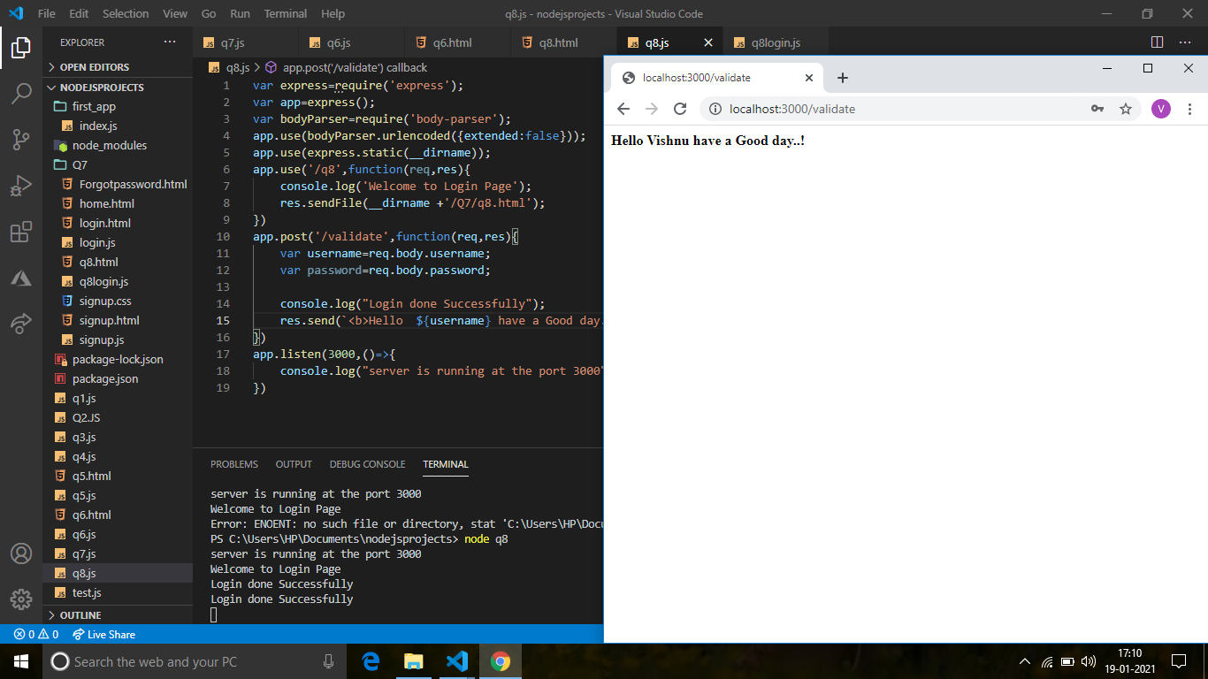

1. Create a Mark Entry page which gets redirected to Marksheet page on Submission. Marksheet page should display the data entered in Entry page.

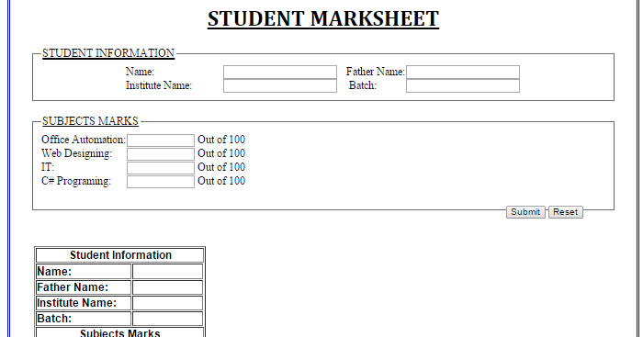

PROGRAM IN HTML:

<!DOCTYPE html>

<head></head>

<body>

    <h1 style="text-align:center"><u>STUDENT MARKSHEET</u></h1>

    <form class="form" action="/validate" method='POST' id="form">

    <fieldset>

        <legend><u>STUDENT INFORMATION</u></legend>

        <table>

             <tr>

                 <td>Name &emsp;&emsp;&emsp;&emsp;&emsp;<input type="text" name="Name">&emsp;</td>

                 <td>Father Name &emsp;&nbsp;&nbsp;<input type="text" name="FatherName"></td>

             </tr>

             <tr>

                <td>Institute Name: &emsp;&nbsp;<input type="text" name="InstituteName">&emsp;</td>

                <td>Batch: &emsp;&emsp;&emsp;&emsp;<input type="text" name="Batch"></td>

            </tr>

        </table>

    </fieldset>

    <br>

    <fieldset>

        <legend><u>SUBJECTS MARKS</u></legend>

        <table>

             <tr>

                 <td>Office Automation &emsp;<input type="text" name="OfficeAutomation">Out of 100&emsp;</td>

             </tr>

             <tr>

                <td>Web Designing &emsp;&emsp;&nbsp;<input type="text" name="WebDesigning">Out of 100&emsp;</td>

            </tr>

            <tr>

                <td>IT &emsp;&emsp;&emsp;&emsp;&emsp;&emsp;&emsp;&nbsp;&nbsp;<input type="text" name="It">Out of 100&emsp;</td>

            </tr>

            <tr>

                <td>C#Programming: &emsp;&ensp;<input type="text" name="Programming">Out of 100&emsp;</td>

            </tr>

        </table>

        <legend><button>Submit</button><button> Reset</button></legend>

    </fieldset>

</form>

</body>

</html>

PROGRAM IN EXPRESS:

var express=require('express');

var app=express();

var bodyParser=require('body-parser');

app.use(bodyParser.urlencoded({extended:false}));

app.use(express.static(__dirname));

app.use('/q9',function(req,res){

    console.log('Welcome to Marksheet Page');

    res.sendFile(__dirname +'/views/q9.html');

})

app.post('/validate',function(req,res){

    var Name=req.body.Name;

    var FatherName=req.body.FatherName;

    var InstituteName=req.body.InstituteName;

    var Batch=req.body.Batch;

    var OfficeAutomation=req.body.OfficeAutomation;

    var WebDesigning=req.body.WebDesigning;

    var It=req.body.It;

    var Programming=req.body.Programming;

    console.log("Login done Successfully");

    res.send(`<b>Student Information</b><br>

    Name:${Name}<br>

    FatherName:${FatherName}<br>

    InstituteName:${InstituteName}<br>

    Batch:${ Batch}<br>

    <br>

    <b>Subjects Marks</b><br>

    OfficeAutomation:${ OfficeAutomation}<br>

    WebDesigning:${ WebDesigning}<br>

    It:${ It}<br>

    Programming:${ Programming}<br>

    `);

})

app.listen(3000,()=>{

    console.log("server is running at the port 3000");

})

OUTPUT:

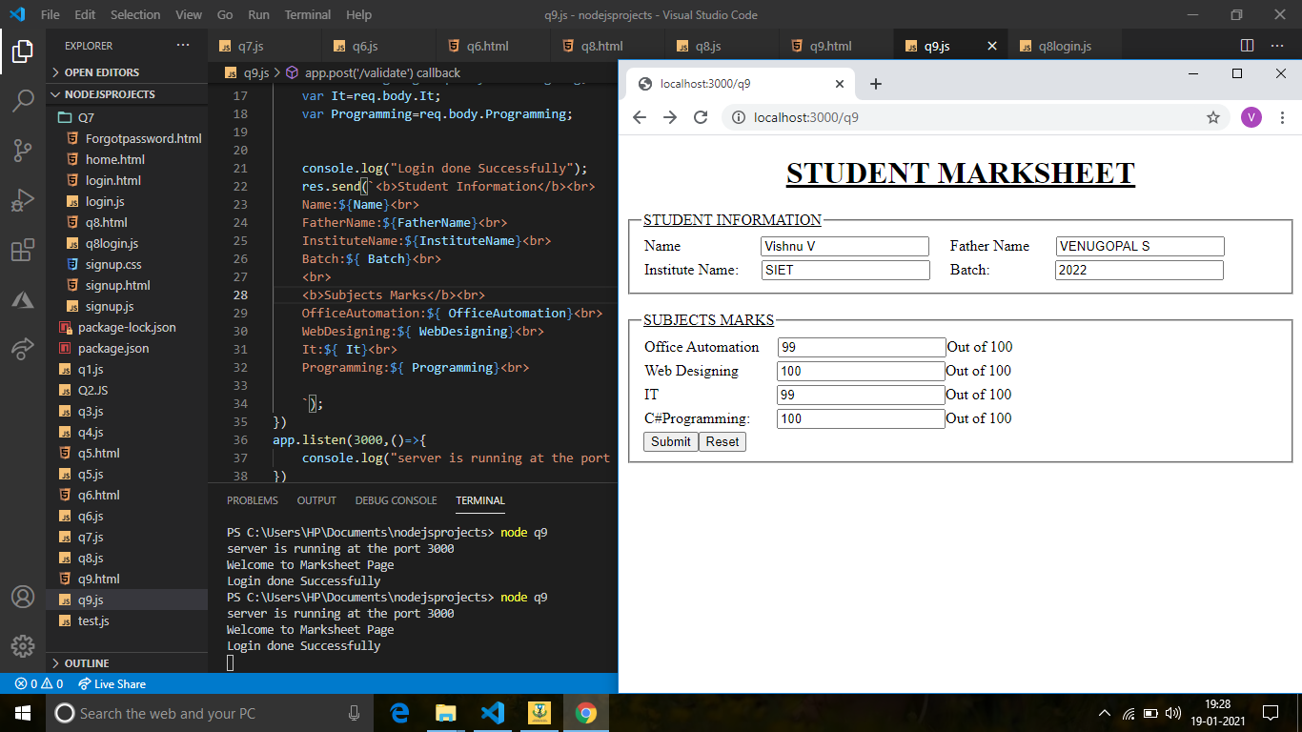

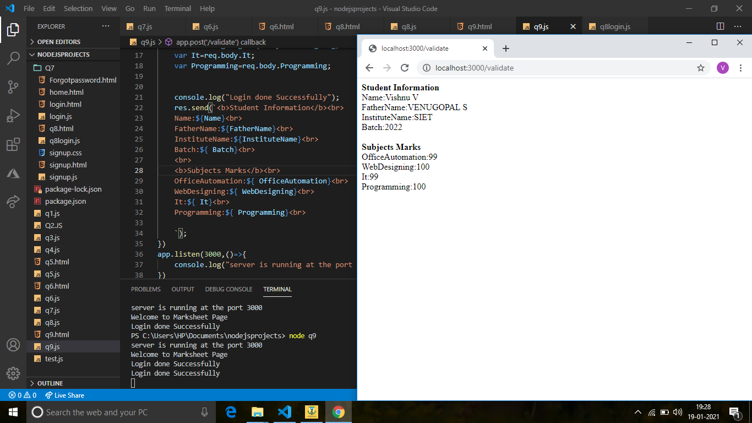

1. Design the Subscription page using Express JS.

Note : Data submitted in this page should get displayed in next page.

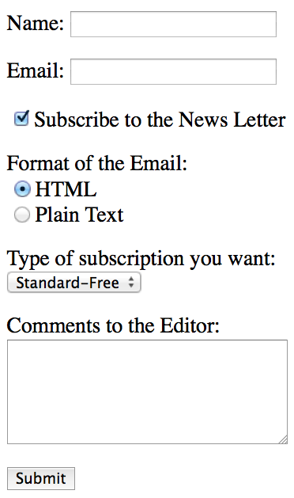

PROGAM IN HTML:

<!DOCTYPE html>

<head></head>

<body>

    <form action='/validate' method='POST'>

        Name: <input type='text' placeholder='Name' name='Name'><br><br>

        Email: <input type='email' placeholder='Email' name='Email'><br><br>

        <input type='checkbox'  name='check' value="Subscribe to the News Letter" checked>Subscribe to the News Letter<br><br>

        Format of the Email:<br><br>

        <input type='radio'  name='radio' value="HTML" checked>HTML<br>

        <input type='radio'  name='radio' value="Plian Text">Plain Text<br><br>

        Type of subscription yo want:<br>

        <select name="drop">

            <option value="Standard-Free">Standard-Free</option>

            <option value="Booked-Free">Booked-Free</option>

            <option >Others</option>

        </select><br><br>

        Comment to the Editor:<br>

        <textarea name="textarea"></textarea><br>

        <button type='submit'> Submit</button></form>

</body>

</html>

PROGRAM IN EXPRESS:

var express=require('express');

var app=express();

var bodyParser=require('body-parser');

app.use(bodyParser.urlencoded({extended:false}));

app.use(express.static(__dirname));

app.use('/q10',function(req,res){

     console.log("Welcome to reg page");

     res.sendFile(__dirname+'/views/q10.html');

})

app.post('/validate',function(req,res){

    var Name=req.body.Name;

    var Email=req.body.Email;

    var radio=req.body.radio;

    var check=req.body.check;

    var drop=req.body.drop;

    var textarea=req.body.textarea;

    console.log("Login done Successfully");

    res.send(`<b>

    Name:${Name}<br>

    Email:${Email}<br>

    yes:subscriber to the news letter<br>

    Format of the Email:<br>

    ${ radio}<br>

     Type of Subscription you want:${ drop}<br>

    Comment to the Editor:${ textarea}<br>

    </b>

    `);

})

app.listen(3000,()=>{

    console.log("server is running at the port 3000");

})

OUTPUT:

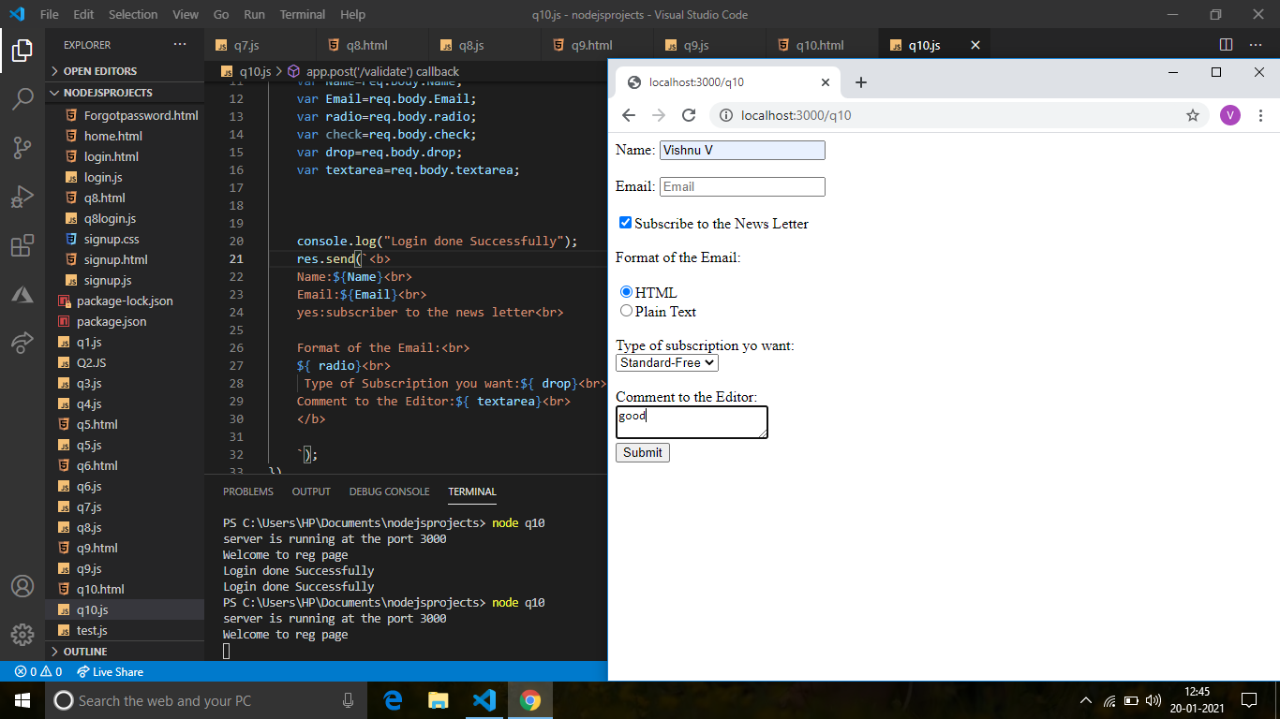

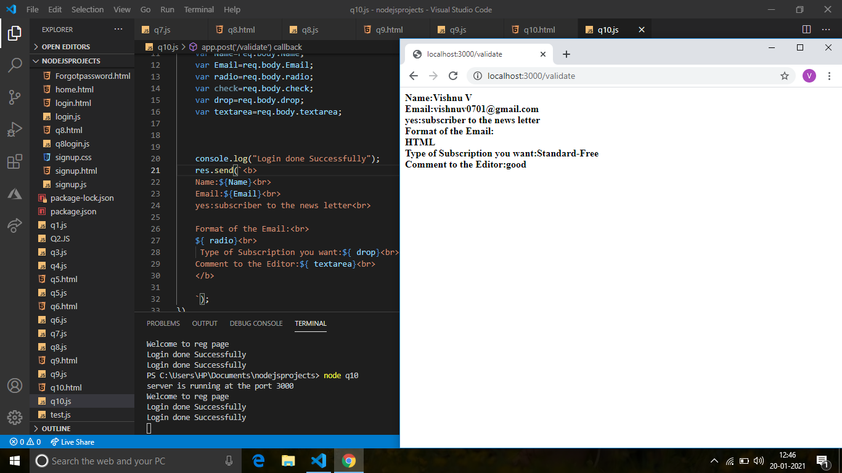

1. Design the below page using ExpressJs. Data submitted in this page should be display in next page with appropriate message.

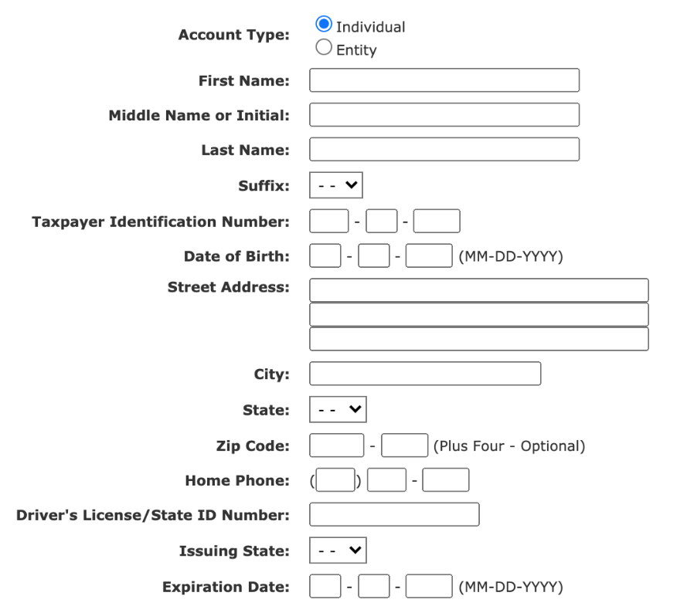

Program in HTML:

<!DOCTYPE html>

<head></head>

<body>

    <form action='/validate' method='POST'>

        <table>

            <tr>

                <td>Account type:</td>

                <td><input type='radio'  name='radio' value="Individual" checked>Individual<br>

                    <input type='radio'  name='radio' >entity<br><br></td>

            </tr>

            <tr>

                <td> First Name:</td>

                <td><input type='text'  name='firstname'></td>

            </tr>

            <tr>

                <td>MiddleName or Initials:</td>

                <td><input type='text'  name='middlename'></td>

            </tr>

            <tr>

                <td>LastName:</td>

                <td><input type='text'  name='lastname'></td>

            </tr>

            <tr>

                <td>Suffix:</td>

                <td><select name='suffix'><option>--</option>

                <option>V</option></select></td>

            </tr>

            <tr>

                <td>Telephone Identification Number:</td>

                <td><input type='text' size='2'  name='ph'> -

                <input type='text' size='2'  name='ph'> -

                <input type='text' size='2'  name='ph'></td>

            </tr>

            <tr>

                <td>Date of Birth:</td>

                <td><input type='text' size='2'  name='dob'> -

                <input type='text' size='2'  name='dob'> -

                <input type='text' size='2'  name='dob'>(MM-DD-YYYY)</td>

            </tr>

            <tr>

                <td>Street Address:</td>

                <td><input type='text'  name='sa'><br>

                    <input type='text'  name='sa'><br>

                    <input type='text'  name='sa'></td>

            </tr>

            <tr>

                <td>City</td>

                <td><input type='text'  name='city'></td>

            </tr>

            <tr>

                <td>State:</td>

                <td><select name='state'><option>--</option>

                <option>TamilNadu</option></select></td>

            </tr>

            <tr>

                <td>Zip Code:</td>

                <td><input type='text' size='2'  name='zc'> -

                <input type='text' size='2'  name='zc'> (Plus Four-Optional)</td>

            </tr>

            <tr>

                <td>Home Phone:</td>

                <td><input type='text' size='2'  name='hp'> -

                <input type='text' size='2'  name='hp'> -

                <input type='text' size='2'  name='hp'></td>

            </tr>

            <tr>

                <td> Driver's License/State Id Number:</td>

                <td><input type='text'  name='license'></td>

            </tr>

            <tr>

                <td>Issuing State:</td>

                <td><select name='is'><option>--</option>

                <option>Tamilnadu</option></select></td>

            </tr>

            <tr>

                <td>Expiration Date:</td>

                <td><input type='text' size='2'  name='ed'> -

                <input type='text' size='2'  name='ed'> -

                <input type='text' size='2'  name='ed'>(MM-DD-YYYY)</td>

            </tr>

        </table>

        <button type='submit'> Submit</button>

    </form>

</body>

</html>

PROGRAM IN EXPRESS:

var express=require('express');

var bodyParser=require('body-parser');

var app=express();

app.use(bodyParser.urlencoded({extended:false}));

app.use(express.static(__dirname));

app.use('/q11',function(req,res){

     console.log('Welcome to reg page');

     res.sendFile(__dirname+'/views/q11.html');

})

app.post('/validate',function(req,res){

    var radio=req.body.radio;

    var firstname=req.body.firstname;

    var middlename=req.body.middlename;

    var lastname=req.body.lastname;

    var suffix=req.body.suffix;

    var ph=req.body.ph;

    var dob=req.body.dob;

    var sa=req.body.sa;

    var city=req.body.city;

    var state=req.body.state;

    var zc=req.body.zc;

    var hp=req.body.hp;

    var license=req.body.license;

    var is=req.body.is;

    var ed=req.body.ed;

    console.log("Login done Successfully");

    res.send(`<b>

    Account Type:${radio}<br>

    FirstName:${firstname}<br>

    MiddleName:${middlename}<br>

    LastName:${lastname}<br>

    Suffix:${suffix}<br>

    telephone num:${ph}<br>

    DOB:${dob}<br>

    Street Address:${sa}<br>

    City:${city}<br>

    State:${state}<br>

    Zip code:${zc}<br>

    Home phn:${hp}<br>

    License:${license}<br>

    Issuing State:${is}<br>

    Expiration date:${ed}<br>

    </b>

    `);

})

app.listen(3000,()=>{

    console.log("server is running at the port 3000");

})

OUTPUT:

